Advertising, Usage, and Certification Guidelines
for Licensed Marks

Red Tomato and Eco Brand Usage Guidelines
Red Tomato®, Eco Apple® (logo and name) and EcoCertified® are registered trademarks, and may be used only with permission from Red Tomato. Eco Peach™ and Eco Stone Fruit™ are trademarks and branded programs developed by Red Tomato and may be used only with permission. Use of any of our trademarks on packaging and advertising materials must be approved in advance by Design/Packaging Director (Diane Rast) at Red Tomato to maintain brand consistency and integrity on behalf of the whole network.

EcoCertified®, Eco Apple®, Eco Peach™, Eco Stone Fruit™: These are trademarks owned by Red Tomato which identify programs developed in partnership with the IPM Institute of North America and our grower network, as well as products sold under those programs. Product may be sold under these trademarks with permission and subject to an appropriate written license, when the current year’s protocol has been followed, production records have been submitted, and the orchard/farm has been certified by IPM Institute. Produce grown outside the protocols or not accepted for certification may not be sold under the EcoCertified®, Eco Apple®, Eco Peach™ or Eco Stone Fruit™ label, although it may still be marketed as conventional product.

Processed products: Some processed goods made with certified fruit may also carry the EcoCertified® Eco Apple®, Eco Peach™ or Eco Stone Fruit™ designation on the packaging, but is subject to a separate licensing agreement. We are happy to provide you with those guidelines, logo artwork (see additional guidelines below) and help with wording and placement.

All uses of the Eco brand logos and designation must be approved in advance by Red Tomato.
There are a few specifications for you to follow: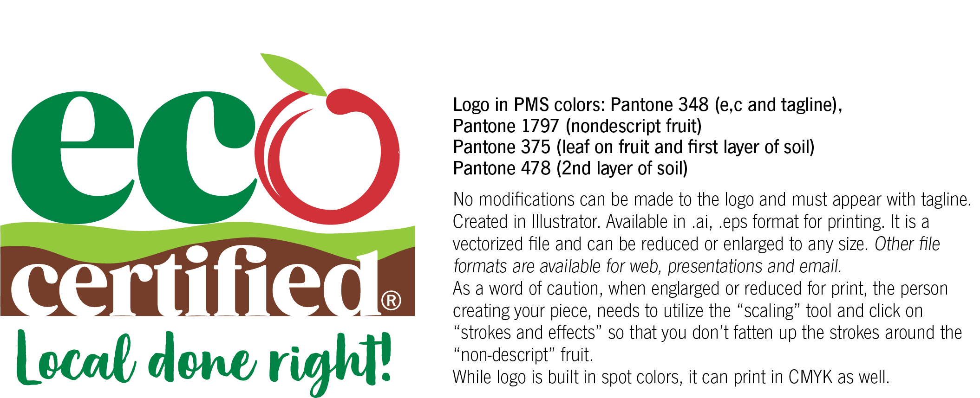

EcoCertified® logo cannot be altered or manipulated. The logo can be used in 3 versions:

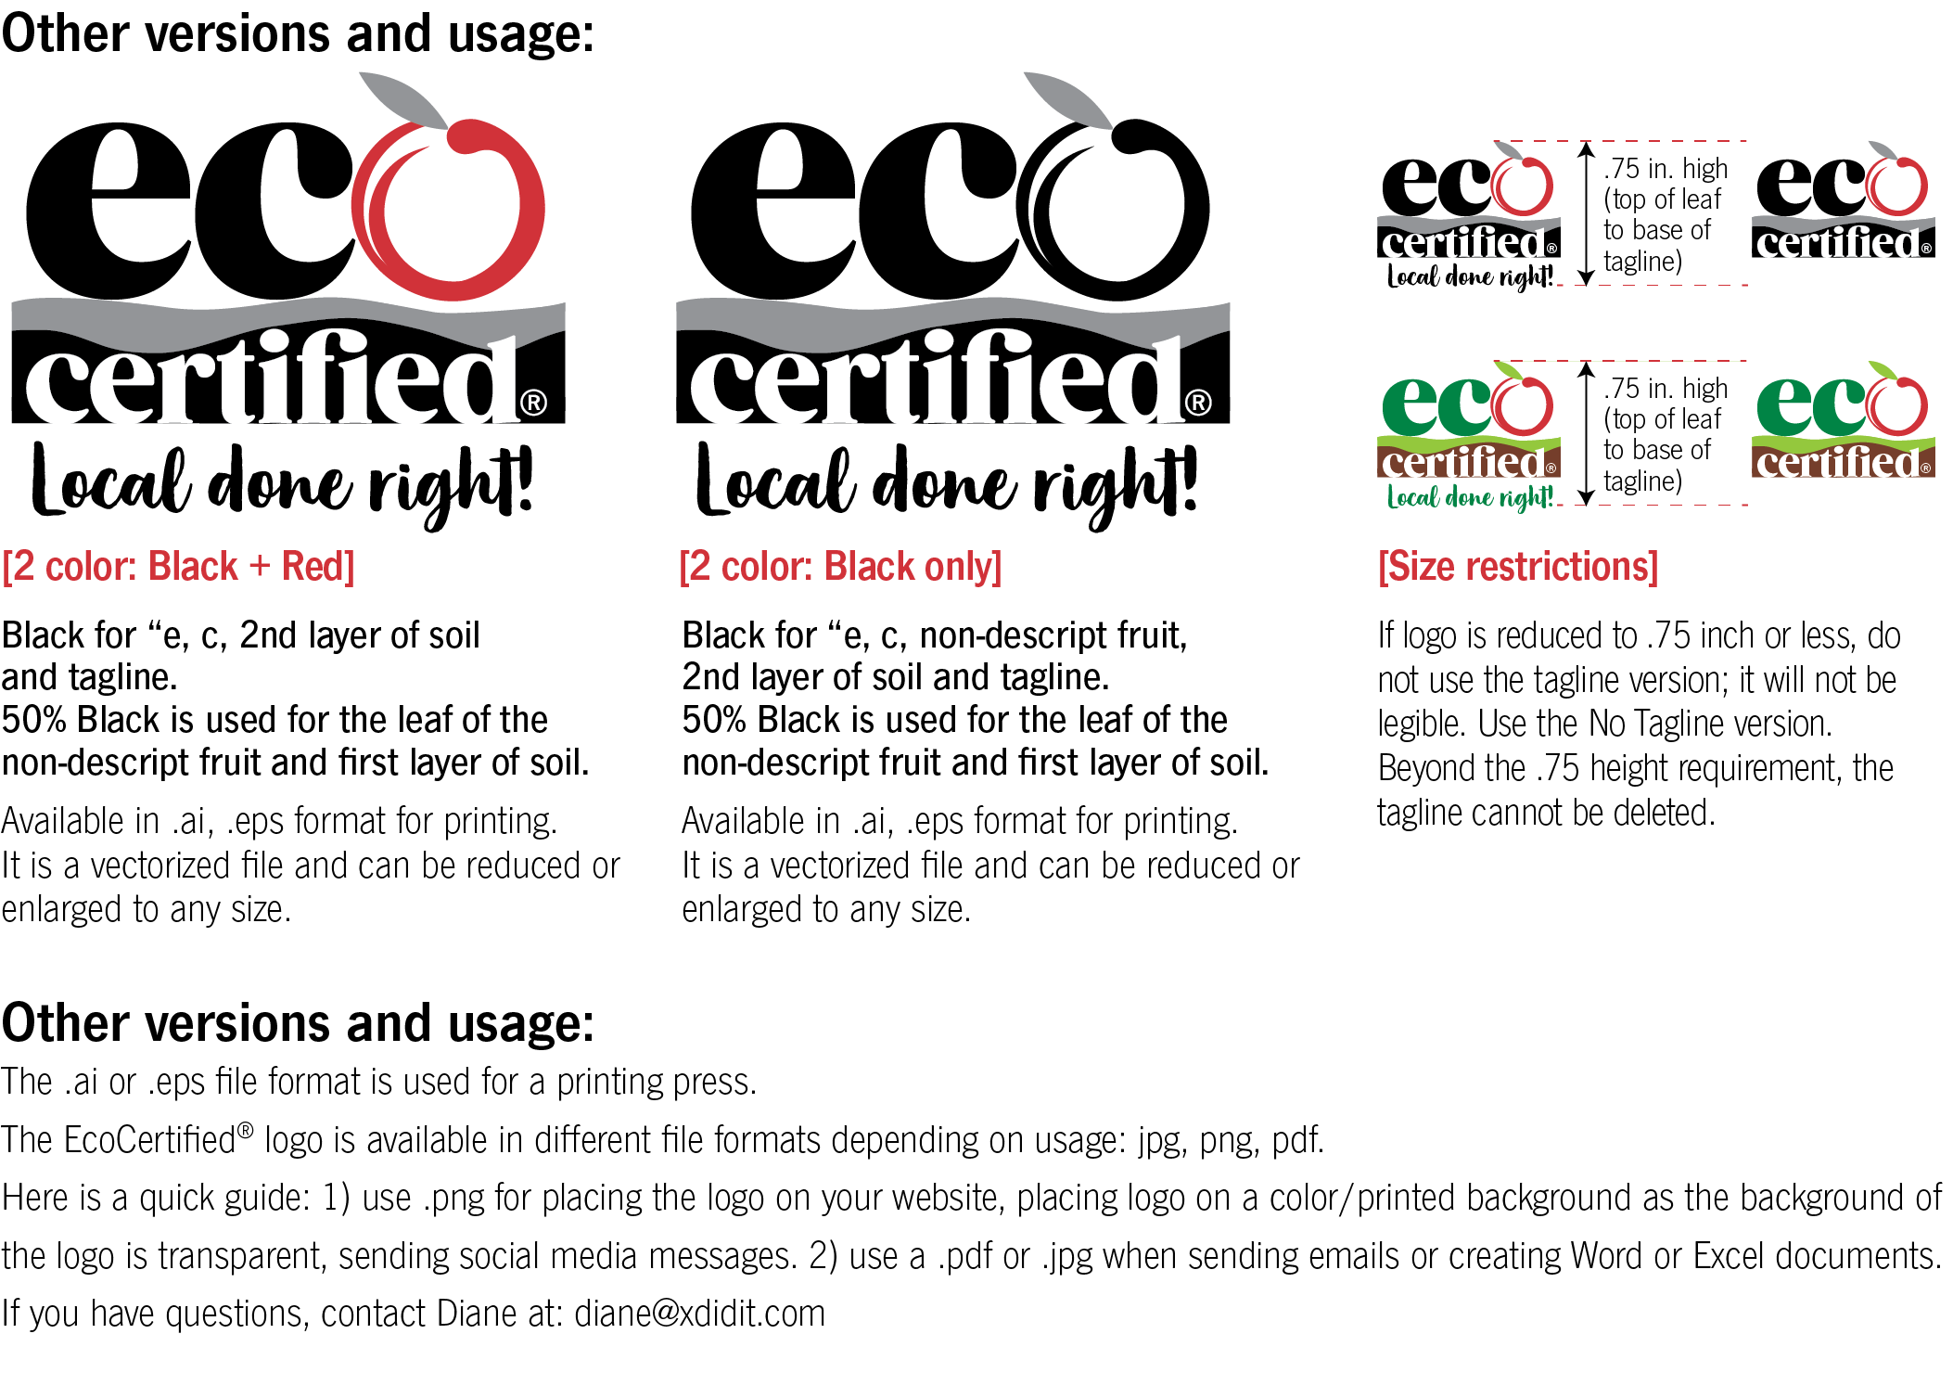

We can provide the logo in color, black +tint only, and with and without the tagline in different file formats.

Eco Apple® or Eco Peach™ logo (old versions): are in the process of being phased out and replaced with EcoCertified®. While still in use, they cannot be altered or manipulated and can be used in 2 versions: 2 color (Black and PMS 363) or output in CMYK. The ® or ™ must accompany the logo at all times.
- If there is any reference in your text that uses Eco Certified®, Eco Apple®, Eco Peach™, or Eco Stone Fruit™ it must be:
  - followed by the ® registered trademark symbol or ™ unregistered trademark symbol as appropriate,
  - must be used as a “proper adjective” only, not as a noun,
  - followed by an appropriate generic term, such as “fruit” or “apples,” and
  - never be used in its plural form. An example of proper use is (“We sell EcoCertified® apples,” or “We sell Eco Apple® fruit.” Examples of improper use include “We sell Eco Apples” and “Enjoy an Eco Apple today.”
  - never shortened, altered or abbreviated from the phrase “EcoCertified®”.
If you have any questions regarding proper use of EcoCertified®, or any of our trademarks, please contact our Marketing Department.
Please supply our marketing department a sample (digital or print) of what you have created for review, prior to publication or circulation.

Website, signs, brochures: We offer some print materials and signs for you to use. In some cases we can customize these to incorporate your farm logo or information such as recipes; contact Red Tomato if you’d like to know more. You are welcome and encouraged to include EcoCertified® information in your own website, signs and materials, subject to these guidelines.

Please be extremely careful to indicate the current year for which your farm is certified, and if the certification does not apply to your entire crop, to clearly identify which product is certified and which is not. If you have been certified in past years but are not certified currently it is essential that you make that clear, and remove or update all references to your certification and participation in the program. Description of the Eco programs and use of the logo on packaging and print material must be approved by Red Tomato Marketing staff or Design/Packaging Director (Rast) at Red Tomato to maintain brand consistency and integrity on behalf of the whole network.

Keep us posted! Let us know about all of the marketing you are doing—your website, Facebook, events, products other than the ones Red Tomato is marketing. We will gladly put links on our website, and help to promote your farm and products through our social media, our e-newsletter, and whenever we have the opportunity.

Note:

Red Tomato® brand: In general, the Red Tomato® brand is not used by anyone other than Red Tomato, and is used to identify products, educational material, events, and programs. Our goal is to build brand recognition and credibility. If you would like to use the Red Tomato® trademark on a product or activity you are working on, start by contacting Red Tomato Marketing and we will help determine how to proceed.

